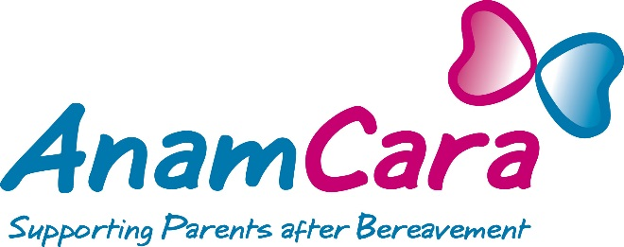

Commitment to Standards in Fundraising Practice

Anam Cara is fully committed to achieving the standards contained within the
Statement of Guiding Principles for Fundraising.

The Statement exists to:

Improve fundraising practice

Promote high levels of accountability and transparency by organisations fundraising from the public

Provide clarity and assurances to donors and prospective donors about the organisations they support.

We Anam Cara have considered the Statement and believe we meet the
standards it sets out. Where we have not complied with the Statement we have provided an explanation here, (not applicable at this time)

Anam Cara’s report on our fundraising activities is available in our most recent
Annual Report which can be found here http://anamcara.ie/wp-content/uploads/2014/09/Anam-Cara-Annual-Report-2013.pdf

We welcome your feedback on our performance via any of the contact points provided (see below).

See our Feedback and Complaints Procedure here http://anamcara.ie/contact-us/feedback-and-complaints-procedures/

Write to:
Sharon Vard
HCL House,
Second Avenue,
Cookstown Industrial Estate,
Tallaght,
Dublin 24

T: 01 4045387
E: info@anamcara.ie
W: www.anamcara.ie
We are open 5 days a week from 9.00 am to 5.00 pm

