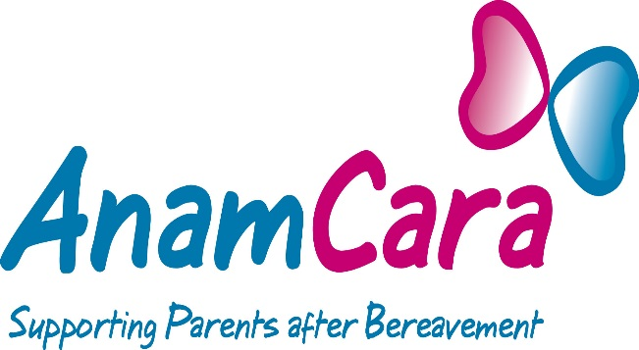

Disclosure

Anam Cara is open about whether those seeking donations on their behalf are volunteers, employees of the organisation or are third party agents.

Anyone fundraising on behalf of Anam Cara must ensure that prospective donors are aware of their status, i.e. volunteers, employees or third party agents.

Note:
If or when a member of the public enquires about the employment standing of a fundraiser they must receive an honest and open answer. The standing in this case relates to whether or not a fundraiser is a volunteer, a paid employee of the charitable organisation or a third party agent working on behalf of the charity.

The recommended form of words is:

- Volunteer: “I volunteer for Anam Cara”

- Employee: “I work for Anam Cara”

- Third Party Agent: “I work for ABC company and we have been engaged by Anam Cara to raise funds for them”

